UNIVERSITY OF NEVADA LAS VEGAS – DEPARTMENT OF ELECTRICAL AND COMPUTER ENGINEERING



Design Assignment 5

CPE 301 Fall 2016

Luis Ruiz

**PART 0**

The assignment took me about 3 hours to do. I had to read the datasheet of the LCD and debug a few times.

1. **PART A: Description**

My design consists of a C program that receives a pin number from a Keypad and outputs a string to the user using the LCD depending on pin entered. The keypad being used is a 4x4 keypad with 8 ports, 4 which are inputs and 4 outputs to be read from the avr. The code determines the pin being pressed, whenever a column read in is low, this character is then stored into a buffer; a message will be displayed until 3 digits are received. At this point a buffer holding the digits will be read and will determine if the system to be unlocked or locked. If locked the user will be asked to enter the pin again, if unlocked the user will receive a message saying “Access Granted”.

**PART B: Code**

**LCD & KEYPAD:**

**lcd.h**

/*

* lcd.h

*/

#ifndef LDC_H

#define LDC_H

#define F_CPU 16000000L

#include <avr/io.h>

#include <util/delay.h>

// Connect LCD data pins to PORTB and control pins to PORTC

// RS = PC.0

// RW = PC.1

// EN = PC.2

#define LCD_CPRT PORTC //LCD COMMANDS PORT

#define LCD_CDDR DDRC //LCD COMMANDS DDR

#define LCD_CPIN PINC //LCD COMMANDS PIN

#define LCD_RS 0 //LCD RS (PC.0)

#define LCD_RW 1 //LCD RW (PC.1)

#define LCD_EN 2 //LCD EN (PC.2)

//****************************************************************

//Function Declarations

/*

* Send a command to the LCD, make pin RS = 1 and R/W = 0;

* Send a H-to-L pulse to the E pin to enable the internal

* latch. Place command in command Reg (output AVR: PortB.0...7)

*/

void lcdCommand (unsigned char cmd){

sendData(cmd); //send cmd to data port

LCD_CPRT &= ~(1<<LCD_RS); //RS = 0 for command

LCD_CPRT &= ~(1<<LCD_RW); //RW = 0 for write

LCD_CPRT |= (1<<LCD_EN); //EN = 1 for H-to-L pulse

*_delay_us*(1); //wait to make enable wide

LCD_CPRT &= ~(1<<LCD_EN); //EN = 0 for H-to_L pulse

*_delay_us*(100); //wait to make enable wide

}

/*

* Send data to the LCD, make pin RS = 0 and R/W = 0;

* Send a H-to-L pulse to the E pin to enable the internal

* latch. Place data in Data Reg (output AVR: PortB.0...7)

*/

void lcdData(unsigned char data){

sendData(data); //send data to data port

LCD_CPRT |= (1<<LCD_RS); //RS = 1 for data

LCD_CPRT &= ~(1<<LCD_RW); //RW = 0 for write

LCD_CPRT |= (1<<LCD_EN); //EN = 1 for H-to-L pulse

*_delay_us*(1); //wait to make enable wide

LCD_CPRT &= ~(1<<LCD_EN); //EN = 0 for H-to_L pulse

*_delay_us*(100); //wait to make enable wide

}

/*

* Initiate the LCD

*/

void lcd_init()

{

DDRB = 0xFF;

LCD_CDDR = 0xFF;

LCD_CPRT &=~(1<<LCD_EN); //LCD_EN = 0

*_delay_us*(2000);

//wait for init

lcdCommand(0x38); //initialize LCD 2 line, 5x7

lcdCommand(0x0E); //display on, cursor on

*_delay_us*(2000); //wait

lcdCommand(0x06); //shift cursor right

}

/*

* Print on to the LCD the 8-bit char value

* lcdData is used to send the data

*/

void lcd_print(char * str){

unsigned char i = 0;

while (str[i]!=0) {

lcdData(str[i]); i++;

}

}

/*

* go to specific LCD locations

*/

void lcd_gotoxy(unsigned char x, unsigned char y){

unsigned char firstCharAdr[] = {0x80, 0xC0, 0x94, 0xD4};// locations of the first character of each line

lcdCommand(firstCharAdr[y-1] + x-1);

*_delay_us*(100);

}

/*

* Clear the LCD and reset the cursor to the home position

*/

void lcd_reset(){

lcdCommand(0x01); //clear LCD

lcdCommand(0x02); // return home: returns the cursor to the home position

*_delay_ms*(500);

}

//send data using portb and portc

void sendData(unsigned char str){

PORTB = 0X0;

PORTC &= ~(1<<PC4); PORTC &= ~(1<<PC5);

if((str & 0x01) == 0)

PORTB|= (0<<PB0);

else

PORTB|= (1<<PB0);

if((str & 0x02) == 0)

PORTB|= (0<<PB1);

else

PORTB|= (1<<PB1);

if((str & 0x04) == 0)

PORTB|= (0<<PB2);

else

PORTB|= (1<<PB2);

if((str & 0x08) == 0)

PORTB|= (0<<PB3);

else

PORTB|= (1<<PB3);

if((str & 0x10) == 0)

PORTB|= (0<<PB4);

else

PORTB|= (1<<PB4);

if((str & 0x20) == 0)

PORTB|= (0<<PB5);

else

PORTB|= (1<<PB5);

if((str & 0x40) == 0)

PORTC|= (0<<PC4);

else

PORTC|= (1<<PD4);

if((str & 0x80) == 0)

PORTC|= (0<<PC5);

else

PORTC|= (1<<PD5);

}

//Test the LCD Functionality

int lcd_test(){

lcd_init();

lcd_print("Demo code"); // print some sample code on LCD

*_delay_ms*(1000);

// clear the LCD and print some more text

lcdCommand(0x01); //clear LCD

lcdCommand(0x02); // return home: returns the cursor to the home position

lcd_print("Here is some more text that overruns a single line..."); // print text that overruns a single line

*_delay_ms*(1000);

// print text at a specific location on LCD (1st line, then 2nd line)

lcdCommand(0x01); //clear LCD

lcdCommand(0x02); // return home: returns the cursor to the home position

*_delay_ms*(1000);

lcd_gotoxy(1,1);

lcd_print("Text for line 1.");

lcd_gotoxy(1,2);

lcd_print("Text for line 2.");

while(1); //stay here forever

return 0;

}

#endif

**Main**

/*

* DA5.c

*

* Created: 3/1/2017 10:19:00 PM

* Author : Luis

*/

#include "lcd.h"

#include <avr/io.h>

//KEYPAD PINS

#define KEYPORT PORTD

#define KEYDDR DDRD

#define KEYPIN PIND

//SET OUTUPT signals

/* Had to map it out differently based on the

// the data sheet

//How it looks on the keypad interface

{

{'1','2','3','A'},

{'4','5','6','B'},

{'7','8','9','C'},

{'*','0','#','D'}

}

*/

unsigned char keypad[4][4] ={

{'1','4','7','*'},

{'2','5','8','0'},

{'3','6','9','#'},

{'A','B','C','D'}

};

int main(void)

{

lcd_init();

lcd_reset();

lcd_print("Input Pin");

unsigned char col,row = 0;

unsigned char count = 0;

unsigned char pin[4] = {0};

while(1)

{

start:

if(count == 0)

{

lcd_init();

lcd_reset();

lcd_print("Input Pin");

lcd_gotoxy(1,2);

col = row = 0;

pin[4] = pin[3] = pin[2]= pin[1]= 0;

}

//Establish the Inputs and outputs

//to the keypad

KEYDDR = 0xF0;

KEYPORT = 0xFF;

/*

* Go in at least once,

* Then PORT7...4 are set low and wait until the pad pressed

* released.

*/

do

{

KEYPORT &= 0x0F;

col = (KEYPIN & 0x0F);

}while(col != 0x0F);

/*

* De-bouncing

*/

do

{

do

{

*_delay_ms*(20); //call delay

col = (KEYPIN & 0x0F); //see if any key is pressed

} while (col == 0x0F); //keep checking for key press

*_delay_ms*(20); //call delay for de-bounce

col = (KEYPIN & 0x0F); //read columns

} while (col == 0x0F); //wait for key press

while(1)

{

KEYPORT = 0xEF; //ground row 0

*_delay_ms*(20);

col = (KEYPIN & 0x0F); //read the columns

if (col != 0x0F) //column detected

{

row = 0; //save row location

break; //exit while loop

}

KEYPORT = 0xDF; //ground row 1

*_delay_ms*(20);

col = (KEYPIN & 0x0F); //read the columns

if(col != 0x0F) //column detected

{

row = 1; //save row location

break; //exit while loop

}

KEYPORT = 0xBF; //ground row 2

*_delay_ms*(20);

col = (KEYPIN & 0x0F); //read the columns

if(col != 0x0F) //column detected

{

row = 2; //save row location

break; //exit while loop

}

KEYPORT = 0x7F; //ground row 3

*_delay_ms*(20);

col = (KEYPIN & 0x0F); //read the columns

if(col!= 0x0F)

{

row = 3; //save row location

break; //exit while loop

}

}

if(count >= 3)

{

for(int i = 0; i < 3; i = i +1)

{

switch(i)

{

case 0: if(pin[i] != '5'){

lcdData(pin);

*_delay_ms*(1000);

printError(pin);

count = 0;

goto start;

}

break;

case 1:if(pin[i] != '2'){

lcdData(pin);

*_delay_ms*(1000);

printError(pin);

count = 0;

goto start;

}

break;

case 2:if(pin[i] != '7'){

lcdData(pin);

*_delay_ms*(1000);

printError(pin);

count = 0;

goto start;

}

else

Correct(pin);

break;

default:count = 0;goto start;break;

}

}

count = 0;

goto start;

}

//check column and send result to Port D

if(col == 0x0E)

pin[count] = (keypad[row][0]);

else if(col == 0x0D)

pin[count] = (keypad[row][1]);

else if(col == 0x0B)

pin[count] = (keypad[row][2]);

else

pin[count] = (keypad[row][3]);

if(count < 3)

{

lcdData(pin[count]);

*_delay_ms*(500);

}

++count;

}

return 0;

}

void printError(char *str)

{

lcd_init();

lcd_reset();

lcd_print(str);

lcd_gotoxy(1,2);

lcd_print("Wrong Pin!!");

*_delay_ms*(2500);

}

void Correct(char *str){

lcd_init();

lcd_reset();

lcd_print(str);

lcd_gotoxy(1,2);

//“System unlocked”

lcd_print("Access Granted!!");

//_delay_ms(2500);

while(1);

}

**PART C:Flow Chart**

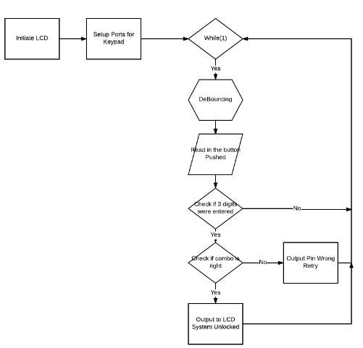

**PART D: Schematic**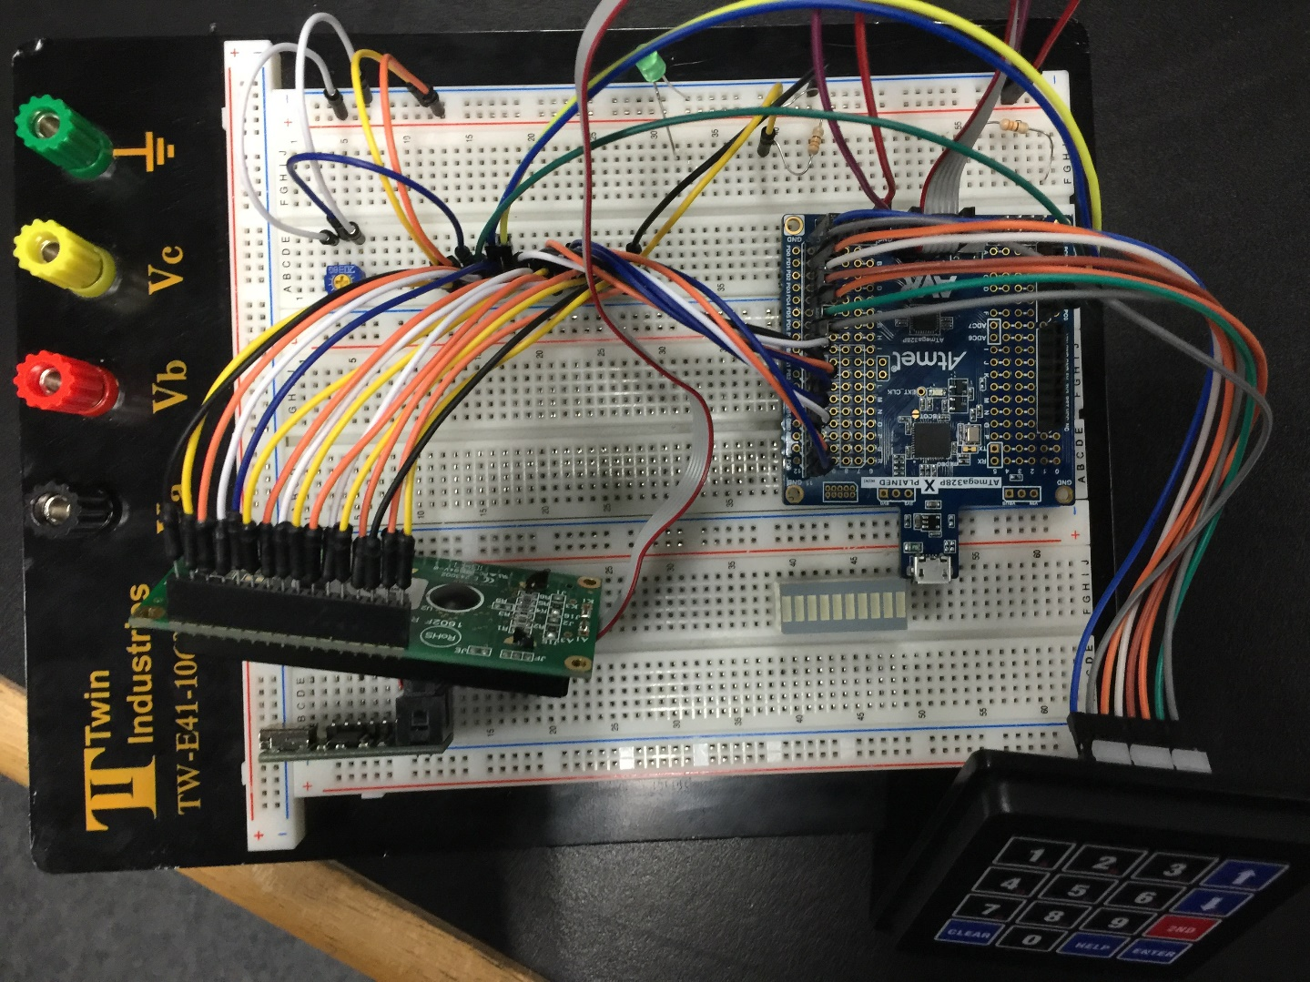

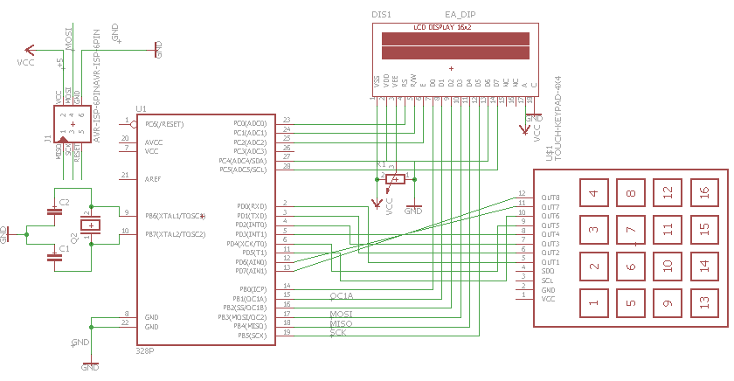

**PART E: Video**URL Video of Design Assignment 5: <https://youtu.be/XtZO00H5-B0>